Output Screenshot:
Simple User Interface asking the user to upload the image:
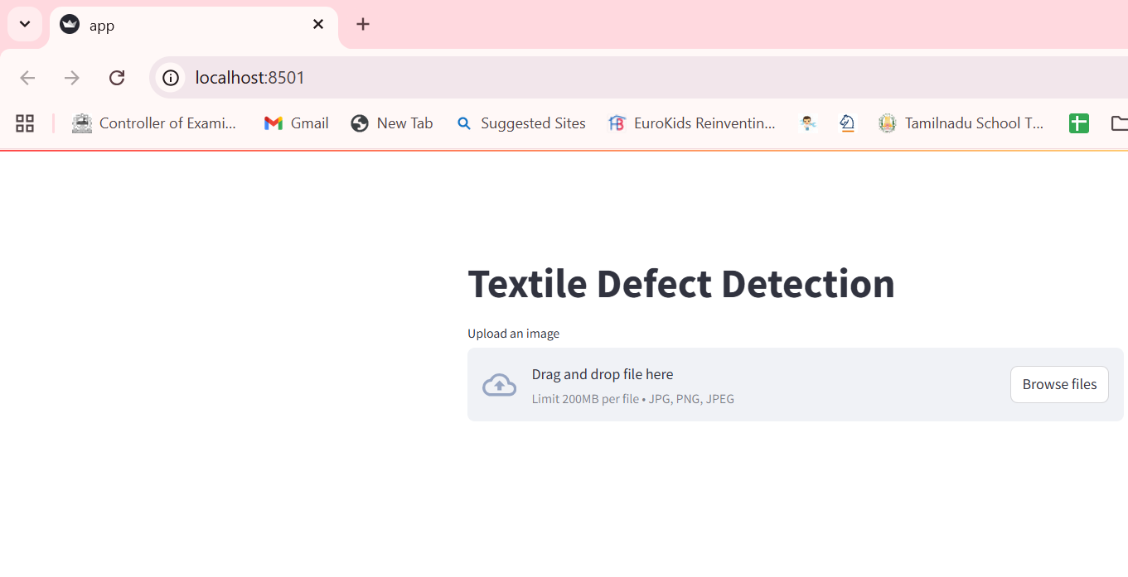
While validating the mode with unseen images, the model even can able to capture the subtle defects.
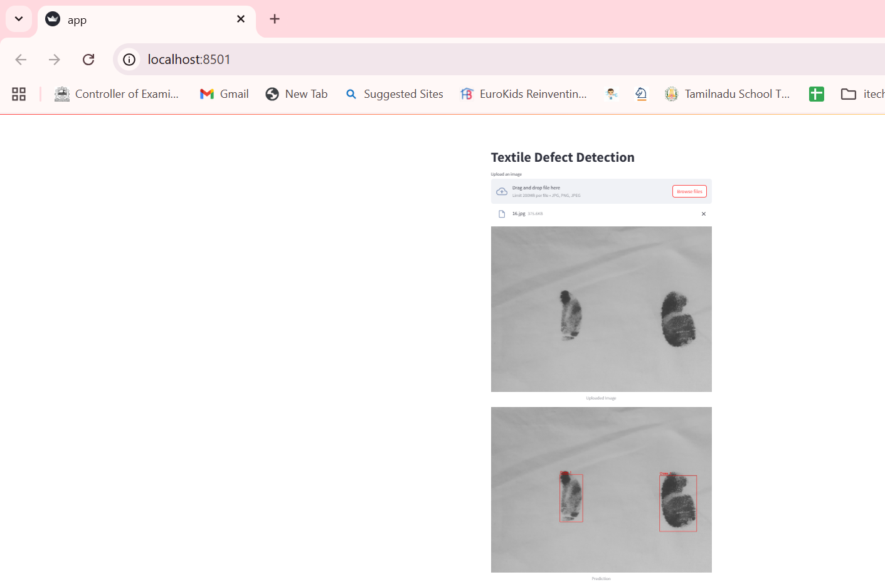

Due to limited computational resources, the Faster R-CNN model was trained minimally with only 2 classes (defect free, stain) and 3 epochs. While this allows detection of textile defects, the model may sometimes detect other objects. This will be carefully handled by fine tuning the model appropriately. Also, the handling of class imbalance and use of generative models for generating any defect or defect free instances will be carefully analyzed.
